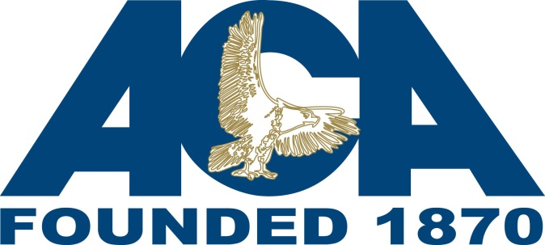

**CONTRACT REQUEST FORM**

***Revised January 2018***

Complete the indicated portions on the form and email the completed form to Megan Noble, ACA Specialist, at [megann@aca.org](mailto:megann@aca.org). This form is fillable so you can type directly into the grey boxes.

|  |  |  |  |  |  |
| --- | --- | --- | --- | --- | --- |
| **CONTRACT REQUEST FORM** | | | | | |
| **Parent Agency** | ***Please provide the name of your Agency.*** | | | | |
| **Facility** | ***Please provide the “actual” name of the facility to be audited.*** | | | | |
| **Address** | ***Physical address of facility to be audited.*** | | | | |
| **Contact Person** | ***Name and title of person to receive the contract and invoice.*** | | | | |
| **Email Address** | ***Email address of person to receive the contract and invoice.*** | | | | |
| **Phone Number** | ***Phone number of person to receive the contract****.* | | | | |
| **Type of Audit** | **PREA** | | | | |
| **Standards** | ***Please indicate which standards the facility will be audited under.*** | | | | |
| Prisons and Jails | Lockup | Community Confinement | | Juvenile Facility |
| **Number of Housing Units** | ***Please indicate the number of housing units within the facility. The definition of a housing unit can be found on the PREA Resource Center website at***  [***https://www.prearesourcecenter.org/node/3209***](https://www.prearesourcecenter.org/node/3209) | | | | |
| Number of Housing Units: | | | | |
| **Inmate Population** | ***Please indicate the inmate population of the facility, at the time of the completion of this form.*** | | | | |
| Current Inmate Population: | | | | |
| **Proposed**  **Audit Dates** | *Please indicate when you would like to have your audit, include one set of alternative dates if the primary dates are not available.*  **Primary Audit Dates:**       **Alternative Audit Dates**: | | | | |
| **Back-to-Back Audits** | **Will this audit be conducted back-to-back with an ACA or PREA Audit?**  **If yes, please indicate the type of audit and the name of the facility.**  *A “back to back” audit arises when two audits occur in the same week; not concurrently but the audits are geographical close enough to be conducted in the same week.* | | | | |
| **STAFF USE ONLY BELOW THIS LINE** | | | | | |
| **Accreditation Specialist** |  | | | **iMIS #:** | |
| **Fee** | **Cost:** | | | | |
| **Fee Breakdown *(If Applicable):*** | | | | |